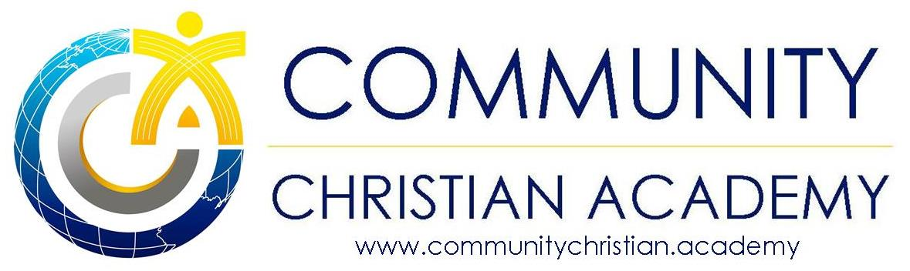
Administrator: Rev. Rafael Najem Principal: Miss Jennifer Najem 105 Princeton Boulevard, Lowell, MA 01851
Tel. 978-453-4738, Fax 978-453-1506, E: academy@ccfcca.com

Statement of Faith

We believe

- That the Bible is the Word of God…the complete, true and inspired Word of God, having the potential to change lives through the ministry of the Holy Spirit.

- In one triune, eternally existent God who has reached out to mankind in the person of Jesus Christ.

3.) In the virgin birth of our Lord Jesus Christ.

4.) In Jesus’ victory over sin through His death on the cross, His bodily resurrection, His return to heaven, and His coming again to earth in power and glory.

5.) That spiritual renewal is the only way to establish eternal life with God.

6.) That without the “New Birth”, man will suffer eternal damnation.

7.) In the baptism of the Holy Spirit.

Enrollment in Community Christian Academy assumes that you are in agreement with the above beliefs.

